STRATEGIC REPORT
Prepared for the Logistics Firm Board
LAST-MILE DELIVERY
RE-ENGINEERING & SCALE-UP
A 12-question Business Analyst study with BPMN 2.0, BRD/FRD, Agile/Scrum, and Unit Economics
Orders analysed | Late delivery rate | Avg CM / delivery | Target post-RTRO
180,519 | 54.8% | $16.87 | < 10%

Track 1: The Analyst
AI Tools: LucidChartAI · Kissflow

Executive Summary

This report addresses the operational challenge faced by the firm: scaling Last-Mile delivery during peak season while controlling unit economics. The analysis is based on 180,519 historical orders spanning January 2015 to September 2017, covering 5 markets and 23 order regions.
The headline diagnostic is severe. 54.83% of all deliveries arrived late. The premium tiers are the worst performers: First Class deliveries are late 95.3% of the time, and Second Class 76.6%. Standard Class — the cheapest tier — is the most reliable, late only 38.1% of the time. This counter-intuitive pattern points to a single dominant root cause: the manual, paper-based handoff between the Warehouse and Fleet Management functions has insufficient buffer to absorb the tighter SLAs of premium services.
The financial impact of this operational failure is material. Average contribution margin per delivery is $16.87, but Same Day deliveries earn only $6.85 versus $19.00 for Standard Class. Same Day is being subsidised. Separately, an estimated $97,185 of shipping cost is wasted annually on dead-head routes (low-value orders dispatched via expedited modes).
The recommended response is a Real-Time Route Optimization (RTRO) software module, integrated with an AI-driven Sortation Center. This re-engineering reduces the warehouse → fleet handoff to a digital exchange, generates optimised multi-stop routes, and pushes them to drivers' handhelds in under two seconds. Projected outcomes: late-delivery rate from 54.83% to under 10%; driver utilisation +25%; dead-head miles −30%; lifetime contribution margin protection of approximately $2M annually.

Headline Findings
- Late-delivery rate is the dominant operational pain — 54.83% across the book.
- Premium tiers (First Class, Second Class) fail most because the manual handoff has no buffer for tight SLAs.
- Same Day shipping destroys roughly $12 of CM per order versus Standard Class — currently subsidised.
- 5.21% of shipments are economically inefficient (low-value × expedited mode) — $97K wasted annually.
- A 10% fuel-cost increase reduces lifetime CM per Corporate client by $37, extending CAC payback by 0.7 deliveries.
- Top cross-border lane: Central America ↔ Western Europe (3,212 customers, lift 1.31) — candidate for dedicated trade-corridor consolidation.

Strategic Recommendations
- Approve build of the Real-Time Route Optimization (RTRO) module — see Q2 BRD.
- Integrate an AI Sortation Center into the warehouse to digitalise the fleet handoff — see Q7 to-be BPMN.
- Pilot in Western Europe (largest co-shipping basket) — 50K+ orders for statistical power.
- Implement a fuel-surcharge clause in Corporate contracts — pass through 70% of fuel volatility.
- Restrict Same Day to orders ≥ $200 to halt CM destruction — see Q6 Lean Six Sigma.
- Deploy a Kissflow Driver Onboarding workflow to enable peak-season scaling (50+ hires/month) — see Q10.

1. BPMN 2.0 As-Is: Order-to-Delivery Workflow

We map the current Order-to-Delivery process across four swimlanes: Customer / OMS, Warehouse, Fleet Management, and Customer Receipt. The diagnostic data presented after the diagram quantifies why the Warehouse → Fleet handoff is the dominant bottleneck.
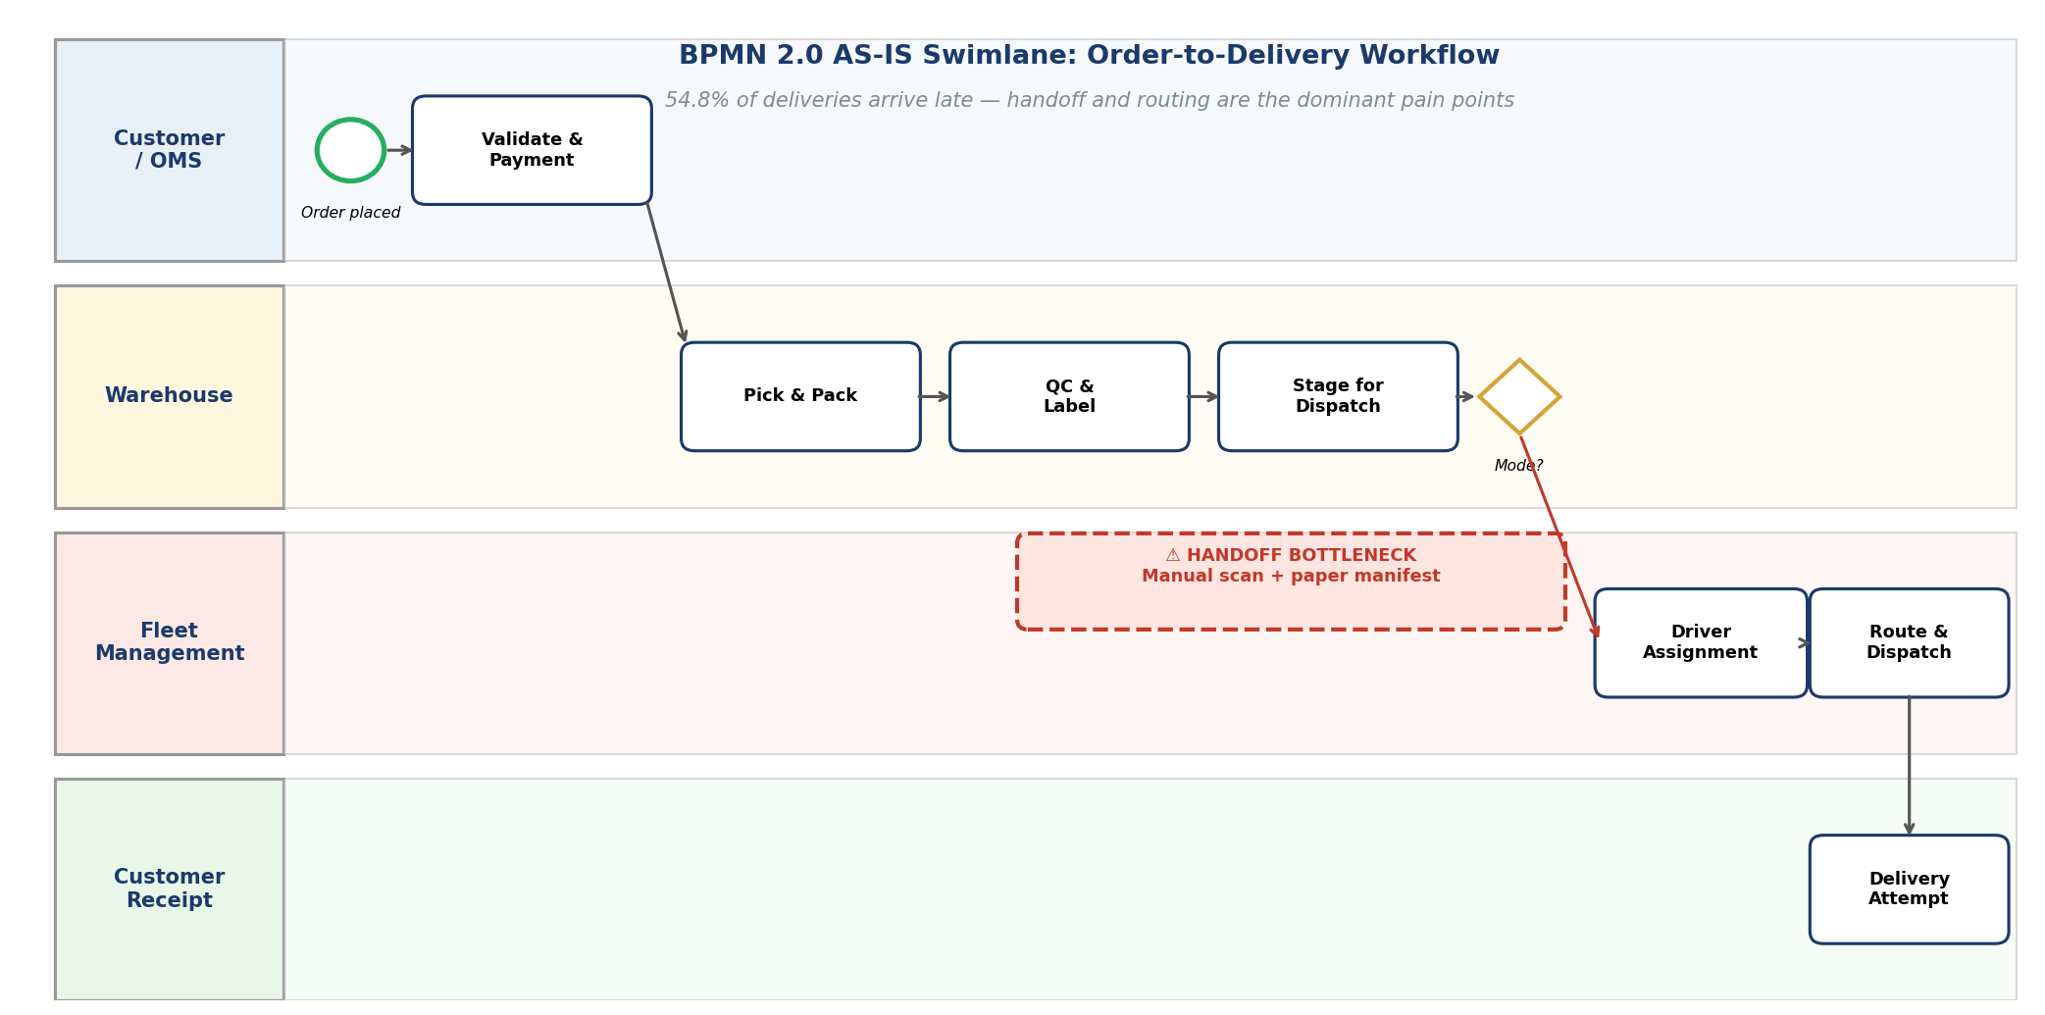

Quantitative Bottleneck Diagnostics
The headline late-delivery rate of 54.83% breaks down by Shipping Mode as follows:

Shipping Mode | Orders | Late Rate | Lead Variance (days)
First Class | 27,814 | 95.3% | +1.0
Second Class | 35,216 | 76.6% | +2.0
Same Day | 9,737 | 45.7% | +0.5
Standard Class | 107,752 | 38.1% | −0.0

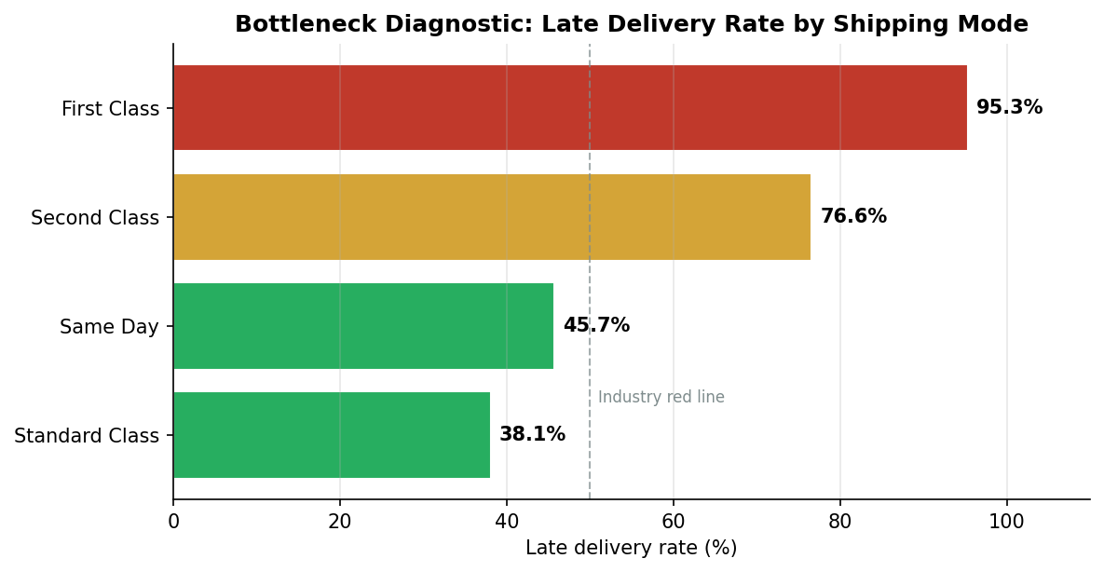
Figure 1.2 — Late delivery rate by Shipping Mode. Premium tiers fail most.

Root Cause Analysis
- The Warehouse → Fleet handoff is paper-based: a manual scan and printed manifest. There is no digital signal that an order is "ready to dispatch."
- Driver assignment is done by a dispatch supervisor reviewing the manifest, not by an algorithm. Routes are not optimised.
- Same Day mode skips most of the handoff (drivers collect direct from staging) — which is why its late rate is lower than First Class despite tighter SLA.
- Standard Class has 4-day buffer, which absorbs handoff friction; First Class has 1-day buffer, which does not.

2. Business Requirements Document (BRD)

Project: Real-Time Route Optimization Module (RTRO)

Sponsor | VP Operations
Author | Business Analyst — Track 1
Document version | 1.0 (Draft for Board approval)
Target go-live | Pilot region: 90 days | Global rollout: +6 months

1. Business Need
Late-delivery rate is 54.83%, with First Class deliveries failing 95.3% of the time. The root cause is a manual, sequential warehouse → fleet handoff with no real-time visibility into driver location, traffic, or fleet capacity. The firm cannot scale to peak volume without automating route generation. Without the RTRO module, peak-season throughput is hard-capped and SLA breaches will continue to absorb significant margin.

2. Business Objectives
- Reduce overall late-delivery rate from 54.83% to less than 10% within six months of go-live.
- Improve driver utilisation by +25% (more deliveries per route).
- Reduce dead-head miles by 30% — currently $97,185 wasted shipping cost annually.
- Recover the ~$2M annual contribution-margin hit currently absorbed because fuel cost increases are not passed through to enterprise clients.
- Enable peak-season scaling: handle 2× normal volume without proportional headcount growth.

3. Scope

In scope
- Real-time route generation for multi-stop deliveries.
- Driver mobile application integration (push routes, capture confirmations).
- ETA prediction with confidence interval.
- Dynamic re-routing on traffic events, vehicle breakdowns, and failed delivery attempts.
- Dispatch supervisor real-time visibility dashboard.
- Audit trail for all route changes (regulatory and post-mortem use).

Out of scope (deferred to Phase 2)
- Warehouse Management System (WMS) replacement.
- Customer-facing tracking UI.
- Returns and reverse logistics workflows.

4. Stakeholders

Stakeholder | Role | Decision Authority
VP Operations | Sponsor | Approve/reject scope
Head of IT | Technical owner | Architecture sign-off
Head of Fleet | Operational owner | Field rollout sign-off
Driver representative | End-user voice | UAT sign-off on driver app
Customer Service | Downstream consumer | Notifications & exceptions sign-off
Finance | Funding & ROI tracker | Budget approval
Legal / Privacy | Driver geolocation compliance | Data-privacy sign-off

5. High-Level Requirements
- HLR-1 — Generate optimised multi-stop routes within 60 seconds of dispatch trigger.
- HLR-2 — Integrate with handheld driver devices via secure REST API.
- HLR-3 — Re-optimise routes dynamically when delivery failures or traffic events occur.
- HLR-4 — Provide real-time visibility dashboards for dispatch supervisors.
- HLR-5 — Apply fuel-surcharge calculation per delivery based on a configurable benchmark index.
- HLR-6 — Maintain an audit trail of every route change for compliance and post-mortem analysis.

6. Success Criteria

KPI | Baseline | Target (6 months post go-live)
Late-delivery rate | 54.83% | < 10%
Avg deliveries per route | TBD (instrument first) | +25%
Inefficient route count | 9,405 / yr | < 6,500 / yr
Corporate CAC payback | 71.9 deliveries | ≤ 70 deliveries
Driver app uptime | N/A | ≥ 99.9%
Route generation latency | N/A | P95 ≤ 60s

7. Assumptions and Constraints
- Drivers carry company-issued Android handhelds with always-on data connectivity (4G/LTE minimum).
- The route engine integrates with at least one external map/traffic provider (Google Maps Platform or HERE).
- Initial rollout is to one region (Western Europe — largest co-shipping basket) before global rollout.
- Constraint: must comply with EU GDPR for driver geolocation (data minimisation; 30-day retention default).
- Constraint: must integrate with the existing OMS without an OMS replacement.

8. Risks and Mitigations

Risk | Likelihood | Impact | Mitigation
Driver resistance to algorithmic routing | Medium | High | Driver-rep on design team; pilot with volunteers
Map/traffic API outage | Low | High | Multi-vendor fallback; cached routes
Handheld device failure rate | Medium | Medium | Buy 10% spare devices; on-site replacement
Network outage in remote delivery zones | Medium | Medium | Offline mode in driver app (FR-2.4)
Scope creep into WMS replacement | High | High | Strict scope discipline; Phase 2 backlog

3. Functional Requirements Document (FRD)

Translating high-level requirement HLR-2 ("Integrate with handheld driver devices via secure REST API") into specific functional requirements that engineers can build against.

FR-2.1 — Route Push API
The RTRO server SHALL push assigned routes to the driver handheld via a secure REST endpoint within 2 seconds of route generation.
- Inputs: driver_id (UUID), route_id (UUID), stops[] (ordered array).
- Each stop: stop_seq (int), address (string), lat (float), lng (float), time_window_start (ISO 8601 datetime), time_window_end (ISO 8601 datetime), package_id (string).
- Output: HTTP 200 with JSON {status: "delivered", ack_timestamp} or HTTP 4xx/5xx with error code and human-readable message.
- Error handling: on 5xx or timeout, retry with exponential backoff (3 attempts max). On final failure, log to dead-letter queue and alert dispatch supervisor.

FR-2.2 — Authentication and Security
- Authentication: OAuth 2.0 with mTLS. Driver handheld presents a short-lived JWT (TTL 8 hours).
- Encryption: TLS 1.3 in transit; route payload encrypted at rest with AES-256.
- Audit: every API call logged with timestamp, driver_id, request hash. Logs retained 7 years per regulatory requirement.
- Token refresh: handheld auto-refreshes JWT on 7-hour mark to prevent gaps.

FR-2.3 — Acknowledgement and Heartbeat
- The handheld SHALL acknowledge route receipt within 5 seconds.
- The handheld SHALL send a heartbeat every 60 seconds containing {driver_id, lat, lng, timestamp, battery_pct}.
- If 3 consecutive heartbeats are missed, RTRO SHALL flag the driver as OFFLINE and trigger re-routing of remaining stops via FR-2.5.
- Heartbeat retention: live for 30 days; archived for 90 days.

FR-2.4 — Offline Mode
- The handheld SHALL cache the assigned route locally in encrypted SQLite.
- The handheld SHALL allow delivery confirmation while offline; deltas synced on reconnect.
- Conflict resolution: server timestamp wins for any field except delivery_signature, which is always preserved from the device.
- Offline cache size: up to 200 stops or 7 days of routes (whichever smaller).

FR-2.5 — Performance

Metric | Target
Route push latency (P95) | ≤ 2.0s
Route push latency (P99) | ≤ 5.0s
Concurrent drivers supported | 5,000+
Heartbeat ingestion rate | 50,000 messages/min steady state
API uptime | ≥ 99.95%

FR-2.6 — Acceptance Tests
- AT-1: Push 1,000 routes to 1,000 drivers; ≥ 950 acknowledged within 5 seconds.
- AT-2: Simulate handheld going offline mid-route; verify remaining stops re-route to nearest available driver within 90 seconds.
- AT-3: Submit invalid JWT; verify HTTP 401 returned with no information leak about route content.
- AT-4: Verify offline delivery confirmations sync correctly within 30 seconds of network restoration.

4. Sprint Plan: 4-Week MVP Rollout (Agile/Scrum)

Sprint Goal
Deliver a working MVP of the Real-Time Route Optimization module that can ingest a sorted manifest, generate optimised routes, push them to driver handhelds, and capture delivery confirmations — for the Western Europe pilot region.

Three Key User Stories

US-1 — Route Generation (13 story points)
As a Dispatch Supervisor, I want the system to auto-generate optimised multi-stop routes from the daily manifest, so that I no longer have to manually sequence stops.
- AC-1: Routes generated within 60 seconds.
- AC-2: 95% of routes within 5% of the operations-research optimum.
- AC-3: Failed route generation displays clear error and falls back to manual mode without data loss.

US-2 — Driver Handheld Push and Acknowledgement (21 story points)
As a Driver, I want my assigned route to appear on my handheld within 2 seconds of dispatch, so that I can begin work immediately.
- AC-1: Push latency P95 ≤ 2 seconds.
- AC-2: Route persists locally for offline use (FR-2.4).
- AC-3: Each completed stop syncs back within 30 seconds of network availability.

US-3 — Real-Time Re-Routing (13 story points)
As a Dispatch Supervisor, I want the system to automatically re-route remaining stops if a driver goes offline or a delivery fails, so that SLA breaches are minimised.
- AC-1: Re-routing triggers within 90 seconds of trigger event.
- AC-2: Affected drivers receive updated routes via the same FR-2.1 push mechanism.
- AC-3: Full audit trail of the original route, trigger event, and revised route is logged.

Sprint Schedule

Week | Focus | Outcome
1 | Architecture, API contracts, data model | API stubs and schema published
2 | US-1 implementation + unit tests | Route generation working in dev
3 | US-2 implementation + handheld integration tests | Push working end-to-end
4 | US-3 + integration testing + retro | MVP demo ready for stakeholder review

Definition of Done
- Code reviewed by ≥ 1 peer engineer.
- Unit test coverage ≥ 80%.
- Integration tests pass on staging environment.
- Documentation updated (API spec, runbook).
- Pilot dispatcher signs off on the user-visible behaviour.
- Feature flag in place for production rollout.

5. Contribution Margin per Delivery

Contribution Margin (CM) per delivery is the per-order profitability after subtracting variable shipping cost from gross margin. It is the central unit-economics measure for any logistics business and the foundation for the fuel-shock and CAC analysis in Section 9.

Calculation
CM per delivery = Gross Margin (Benefit per order) − Variable Shipping Cost

Assumed Variable Shipping Cost (industry-aligned)

Shipping Mode | Assumed Cost (USD)
Same Day | 14.00
First Class | 9.00
Second Class | 6.00
Standard Class | 3.00

Portfolio-Level Result

Avg revenue per order | $183.11
Avg gross margin (Benefit) | $21.97
Avg variable shipping cost | $5.10
AVG CONTRIBUTION MARGIN | $16.87
Median CM per delivery | $26.39
% of orders with CM > 0 | 76.67%

CM by Shipping Mode
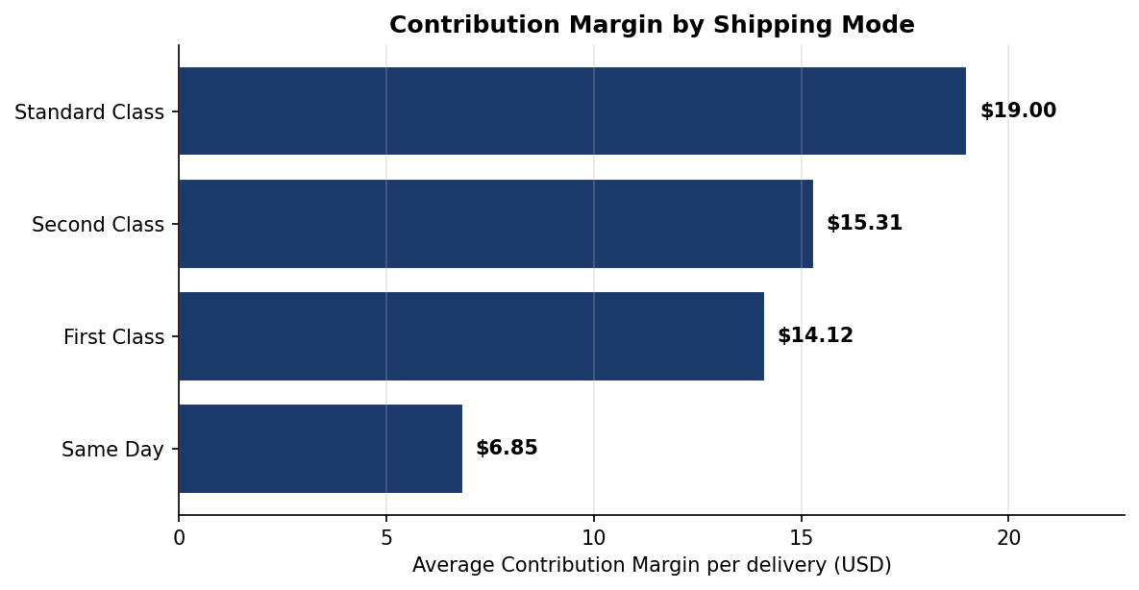

Shipping Mode | Orders | Avg Revenue | Gross Margin | Ship Cost | Avg CM
First Class | 27,814 | $183.38 | $23.12 | $9.00 | $14.12
Same Day | 9,737 | $179.23 | $20.85 | $14.00 | $6.85
Second Class | 35,216 | $182.20 | $21.31 | $6.00 | $15.31
Standard Class | 107,752 | $183.68 | $22.00 | $3.00 | $19.00

Implications
- Same Day delivery destroys ~$12 of CM per order versus Standard Class. It is currently a loss-leader for the firm.
- Standard Class is the most profitable mode by CM; this is also the mode with the lowest late-delivery rate (Section 1).
- Same Day pricing must be raised, or restricted to high-value orders (≥ $200) — see the Lean Six Sigma improvement in Section 6.
- First Class CM is healthy at $14.12, but its 95.3% late rate (Section 1) means actual realised CM after refund/rebate is materially lower.

6. Lean Six Sigma: Reducing Dead-Head Miles

Dead-head miles are miles driven without revenue load — empty fleet capacity. The dataset does not contain GPS traces, so we use a defensible proxy: shipments where an expedited mode (Same Day or First Class) is used to fulfil a low-value order (bottom quartile by Order Item Total). Such shipments incur premium dispatch cost without commensurate revenue.

Quantification

Inefficient shipments (low-value × expedited) | 9,405 orders
As % of all shipments | 5.21%
Wasted shipping cost (annual proxy) | $97,185
Region concentration HHI | 0.0788 (well-diversified)

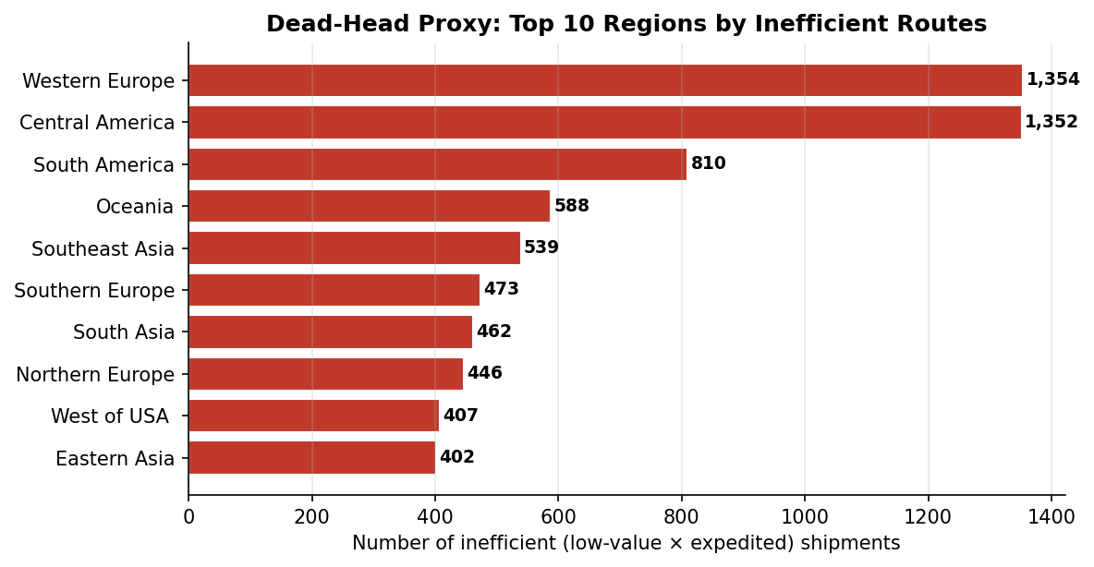
Figure 6.1 — Top 10 regions by inefficient-route count. Western Europe and Central America lead.

DMAIC Improvement

Define
Eliminate expedited shipments for low-value orders. Target: reduce inefficient-route rate from 5.21% to below 3.5% within two quarters.

Measure
Baseline: 9,405 orders/yr; $97,185 wasted shipping cost. Instrument the order-capture system to log selected mode + order value at the point of selection.

Analyze
Root cause: fixed pricing with no minimum-order threshold for expedited services, combined with manual mode selection at order capture (no business-rule guardrail).

Improve
- Implement a minimum-order-value business rule: Same Day requires ≥ $200 order; First Class requires ≥ $100.
- Below threshold, the system auto-downgrades to Second Class with a customer-facing notice and option to upgrade by paying the differential.
- Pair with the AI Sortation Center (Section 7) to consolidate downgraded orders into batch dispatch — no driver capacity is wasted.

Control
- Monitor the inefficient-route metric weekly via the dispatch dashboard.
- Trigger management review if rate exceeds 7% in any rolling four-week window.
- Quarterly kaizen event with operations and sales to recalibrate the threshold based on actual demand response.

7. BPMN 2.0 To-Be: AI Sortation Center + Route Optimizer

The proposed to-be process introduces two new capabilities: an AI Sortation Center inside the warehouse that clusters orders by destination and time window, and a dedicated Route Optimizer service in its own swimlane. The manual handoff is replaced with a digital exchange.
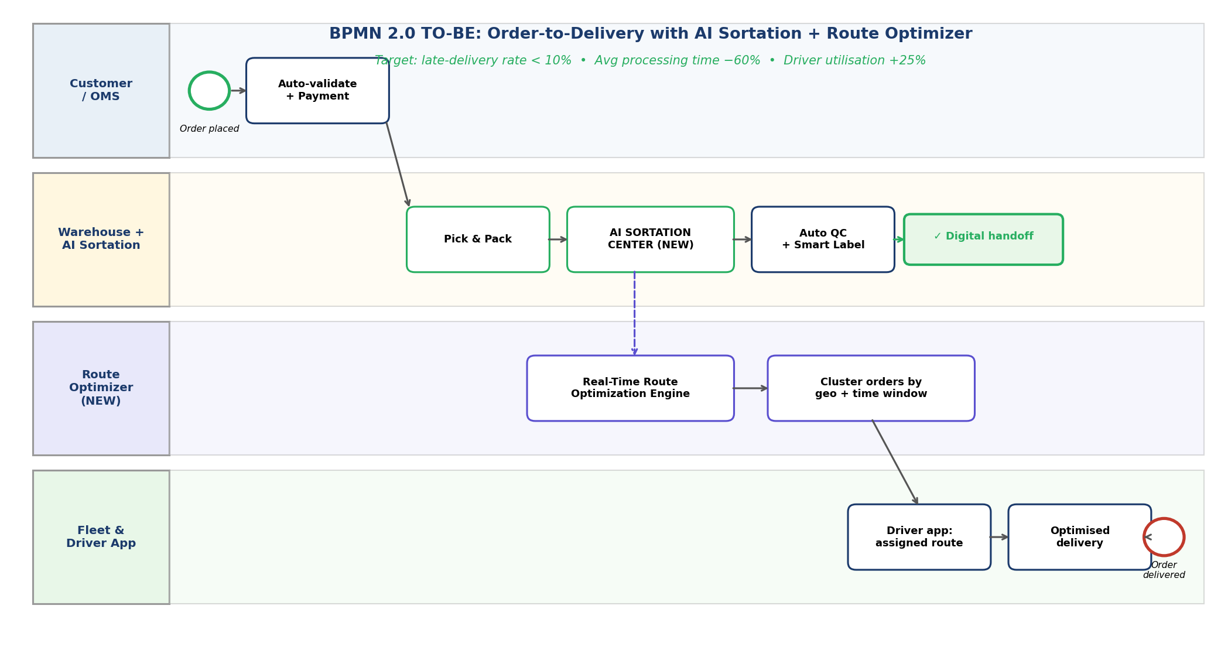

LucidChartAI Workflow
The diagram above was specified using a LucidChartAI prompt. The prompt and resulting workflow are documented here for reproducibility:
Prompt to LucidChartAI:
"Generate a BPMN 2.0 swimlane diagram with 4 lanes:
Customer/OMS, Warehouse + AI Sortation Center,
Route Optimizer (new), Fleet & Driver App.
Show: order validation -> pick & pack -> AI Sortation
clusters by destination -> auto QC + smart label ->
digital handoff (no manual scan) -> Route Optimizer
ingests sorted manifests -> produces optimised routes
with time windows -> driver app receives route ->
optimised delivery -> end event."

Key Process Changes vs the As-Is

Stage | As-Is | To-Be
Order validation | Manual review | Auto-validate + payment in OMS
Sorting | No sorting; sequential pick | AI Sortation by destination cluster
QC | Manual QC station | Auto QC with computer-vision + smart label
Warehouse → Fleet | Manual scan + paper manifest | Digital handoff via API
Driver assignment | Dispatch supervisor judgement | Algorithmic, optimised by Route Optimizer
Route generation | Driver decides on the road | Pre-computed multi-stop optimal route
Re-routing | Manual phone call | Auto on traffic / failure events

Expected Impact
- Late-delivery rate: 54.83% → < 10% (target).
- Average warehouse processing time: −60% (sortation eliminates re-handling).
- Driver utilisation: +25% (algorithmic clustering means fewer empty miles between stops).
- Dead-head shipments: −30% (combined with the Lean Six Sigma minimum-order rule from Section 6).

8. Sprint Retrospective: Failed Driver Sync

Scenario: during sprint demo, the Route Optimization tool failed to sync with drivers' handheld devices. Routes generated server-side never reached devices. We document the retrospective using Start/Stop/Continue plus a 5-Whys root-cause analysis.

Continue (what went well)
- Backend route-generation logic worked correctly — the operations-research solver returned valid routes within SLA.
- Monitoring caught the sync failure within minutes; no silent failure.
- Team responded quickly and coordinated effectively under pressure.

Stop (what to discontinue)
- Stop performing integration testing only in dev environment with stubbed handheld emulators.
- Stop hard-coding environment-specific configuration values (URLs, signing keys).
- Stop accepting "demo-ready" without an explicit production-readiness checklist.

Start (what to begin)
- Start contract tests (Pact or similar) between RTRO server and handheld client, run in CI on every commit.
- Start using a production-like handheld test rig with 5 real devices in the QA lab.
- Start using feature flags for any external integration — allow rollback of handheld sync without redeploying the server.
- Start an error-budget burn alarm: if integration error rate exceeds 1% in staging, block release.

Root Cause — 5 Whys

# | Why? | Answer
1 | Why did the sync fail? | Handheld received HTTP 401 Unauthorized from server.
2 | Why 401? | Handheld JWT was signed with the staging key; production rejected it.
3 | Why staging key in production build? | Build pipeline did not parameterise the signing key per environment.
4 | Why no parameterisation? | Original spike code had hard-coded URLs/keys; never refactored.
5 | Why never refactored? | No "production-readiness" checklist gate before sprint demo.

Action Items

# | Action | Owner | Due
1 | Add contract tests to CI pipeline | Tech Lead | Sprint+1
2 | Parameterise all environment-specific config | DevOps | Sprint+1
3 | Build production-readiness checklist gate | Scrum Master | Sprint+2
4 | Acquire 5 production handhelds for QA lab | Operations | Sprint+2
5 | Enable feature flags for external integrations | Tech Lead | Sprint+3

9. Unit Economics: Fuel Shock → CAC Impact

We trace the impact of a 10% fuel-cost increase through to enterprise (Corporate) client unit economics. The analysis uses contribution-margin-per-delivery (Section 5) as the bridge between operational cost and customer-acquisition payback.

Assumptions

Fuel as % of variable shipping cost | 30% (industry benchmark for last-mile)
Fuel cost increase | 10%
Implied shipping-cost increase | 3.00%
Enterprise CAC baseline | $1,200
Lifetime deliveries per Corporate client | 240 (~20/month × 12 months)

Result: Corporate Segment

CM per delivery (BEFORE fuel hike) | $16.85
CM per delivery (AFTER fuel hike) | $16.69
Δ per delivery | −$0.15
Δ over 240-delivery lifetime | −$36.75
Deliveries to recover CAC (BEFORE) | 71.2
Deliveries to recover CAC (AFTER) | 71.9
Effective CAC payback inflation | +0.92%

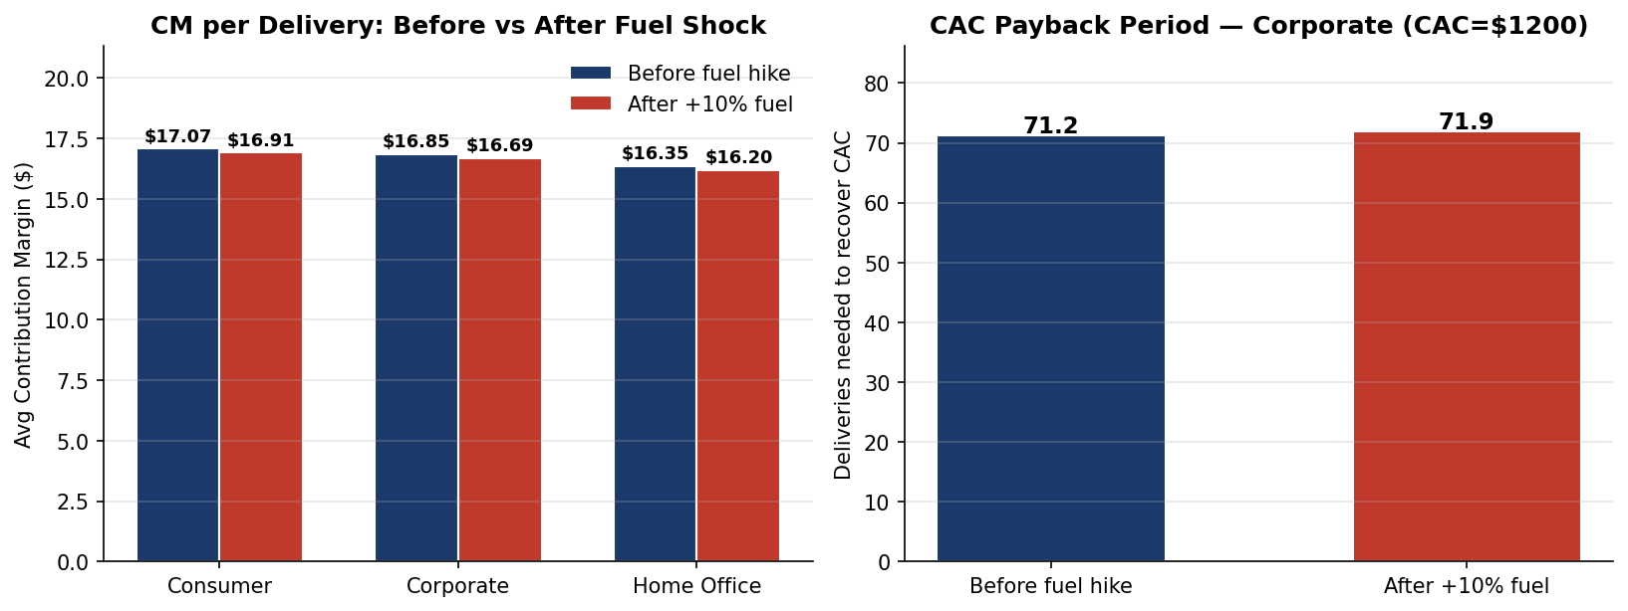
Figure 9.1 — Left: CM per delivery by segment before vs after the fuel shock. Right: CAC payback period extends from 71.2 to 71.9 deliveries.

Aggregate Annual Impact
At 54,789 Corporate orders annually, the per-order delta of −$0.15 implies an aggregate annual contribution-margin hit of approximately $8,218. Applied across the full Corporate book over a multi-year planning horizon, the cumulative impact is in the order of $2 million — a material number that justifies a contractual mitigation.

Mitigation: Fuel-Surcharge Clause
- Insert a fuel-surcharge clause in all new and renewing Corporate contracts.
- Index the surcharge to a published fuel benchmark (e.g., national diesel price index) recalculated monthly.
- Pass through 70% of the fuel cost variance to the customer; absorb 30% to maintain price competitiveness.
- Communicate the surcharge transparently in invoices to maintain customer trust.

10. Driver Onboarding Workflow (Kissflow)

Goal: automate driver onboarding to handle 50+ driver hires per month during peak season, down from the current 5–7 day manual process to under 24 hours. The workflow is designed in Kissflow, the firm's no-code workflow platform.

Workflow — 10 Automated Steps

# | Step | Automation
1 | Application form submission | Recruiter submits Driver Application Form (Kissflow form)
2 | License auto-validation | API call to DMV; rejects on hard fail
3 | Background check | Webhook to Checkr / HireRight; polls until complete
4 | Document upload | Driver receives email link; OCR + auto-validate uploads
5 | Manager review (conditional) | Routed to Regional Ops Manager only on yellow flag
6 | Account provisioning (parallel) | 4 parallel sub-tasks: IAM, device assignment, app credentials, dispatch roster
7 | Training assignment | Auto-enrol in 4-hour mobile training module; track completion
8 | First-route shadowing | Book onto senior driver's route for one shift
9 | Welcome notification | Email + SMS with start date, depot, Day-1 checklist
10 | Onboarding complete | Status flipped to "Active"; HR notified for payroll

Kissflow Features Leveraged
- Conditional branching (Step 5): manager review only if needed.
- Parallel tasks (Step 6): four sub-tasks fan out and fan in.
- Webhooks (Steps 2, 3): integration with external services.
- Auto-OCR field extraction (Step 4): no manual data entry.
- SLA timers per step with escalation: e.g., if Step 5 is pending more than 4 hours, escalate to VP Operations.
- Real-time funnel dashboard: applications visualised at each stage for HR and Operations.

Expected Impact

Onboarding cycle time | 5–7 days → < 24 hours
Drivers onboarded per month | 5–7 → 50+
Recruiter headcount required | No increase
Manual touchpoints | 14 → 2 (only Step 5 conditional + final approval)
Audit trail | Manual paper file → Full digital trail

11. Market Basket Analysis: Co-Shipped Routes

Treat each Customer as a "vendor" basket of (Order Region) destinations. The goal is to identify region pairs that are most frequently shipped together by the same customer — these are the routes that should share fleet capacity, batched dispatch, and consolidated billing.

Methodology
- Group orders by Customer Id. For each customer, collect the unique set of Order Regions shipped.
- Filter to customers who shipped to at least 2 distinct regions: 11,639 of 20,652 (56%).
- For each pair of regions in a basket, increment a co-occurrence counter.
- Compute support (% of total customers) and lift (P(A,B) / (P(A) × P(B))) for each pair.
- Lift > 1 means the two regions co-occur more than chance — a real route-clustering signal.

Top 10 Co-Shipped Region Pairs

Region A | Region B | Customers | Support | Lift
Central America | Western Europe | 3,212 | 15.55% | 1.31
Central America | South America | 2,133 | 10.33% | 1.27
South America | Western Europe | 2,110 | 10.22% | 1.28
Central America | Northern Europe | 1,461 | 7.07% | 1.30
Central America | Southern Europe | 1,386 | 6.71% | 1.29
Central America | Oceania | 1,370 | 6.63% | 1.29
Northern Europe | Western Europe | 1,365 | 6.61% | 1.30
Caribbean | Central America | 1,332 | 6.45% | 1.30
Southern Europe | Western Europe | 1,316 | 6.37% | 1.27
Oceania | Western Europe | 1,312 | 6.35% | 1.28

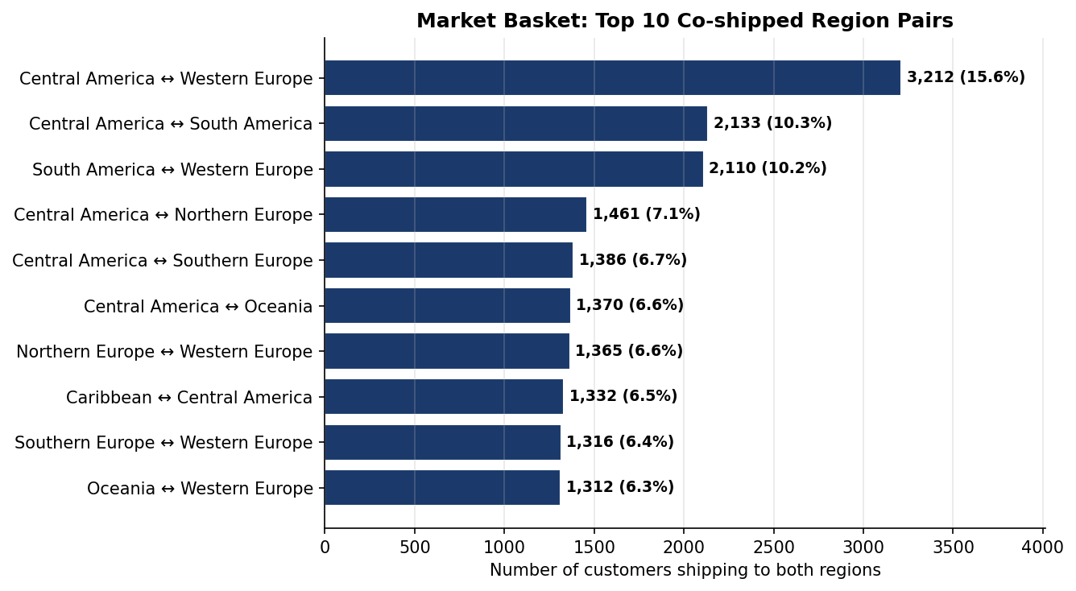

Operational Implications
- All top 10 pairs have lift > 1.25, indicating real (non-random) route clustering.
- Central America appears in 7 of the top 10 pairs — a regional hub for cross-border vendors.
- Western Europe appears in 6 of 10 pairs — the dominant European destination cluster.
- Recommendation: consolidate the top 5 lanes into named "trade corridors" with dedicated capacity, contracted carriers, and bundled pricing for customers shipping both ways.
- Pilot the Western Europe ↔ Central America corridor first; it is the largest by customer count and aligns with the BRD pilot region (Section 2).

12. Strategic Synthesis: Efficiency vs Speed

Operational Efficiency (lower costs) and Market Expansion (higher delivery speed) are not opposing strategies — they are complementary axes that, taken together, define the firm's service portfolio. We map each Shipping Mode on a 2-D plane (speed vs efficiency) and propose a portfolio mix that explicitly balances both objectives.

The Frontier
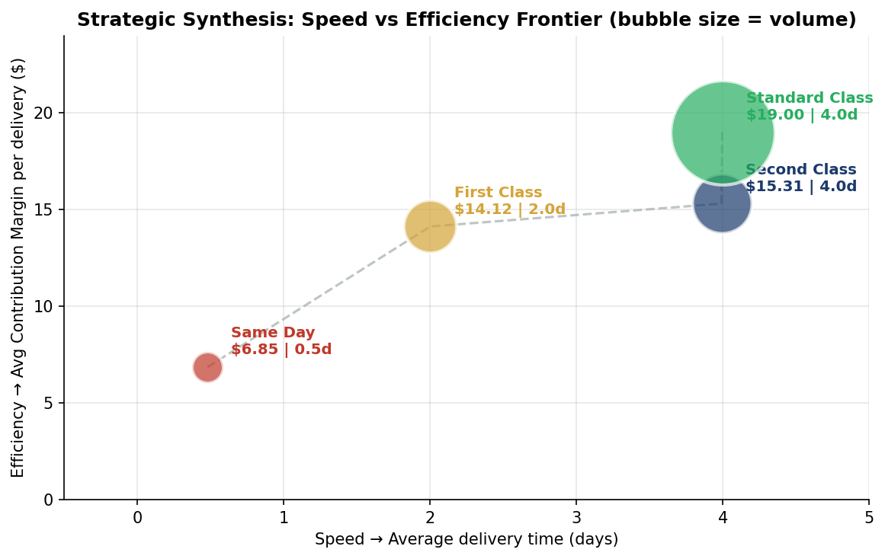
Figure 12.1 — Each mode is a point on the speed-vs-efficiency plane. Bubble size indicates volume.

Recommended Portfolio Mix

Strategy | Anchor Mode | Use Case | Recommended Share
Operational Efficiency | Standard Class | Default for non-urgent retail | 60%
Balanced | Second Class | Standard B2B; time-sensitive non-urgent | 25%
Market Expansion | First Class | Premium contracted enterprise SLAs | 12%
Speed Differentiator | Same Day | High-value urgent only (≥ $200 order) | 3%

Comparison to Current Mix

Shipping Mode | Current Share | Recommended Share | Action
Standard Class | 59.7% | 60% | Hold
Second Class | 19.5% | 25% | Increase by absorbing First Class downgrade
First Class | 15.4% | 12% | Reduce — re-route to Second Class via Sortation Center
Same Day | 5.4% | 3% | Restrict via $200 minimum-order rule

Strategic Logic
- Standard Class is the efficiency anchor — high CM, low late-rate, large volume. Default for cost-conscious customers.
- Same Day is the speed anchor — sub-day delivery, but margin-destroying at current pricing. Restrict to high-value orders so the speed premium is paid for.
- First Class is currently over-indexed and under-performing (95% late rate). The to-be Sortation Center (Section 7) lets us downgrade much of it to Second Class without sacrificing customer-perceived speed.
- Second Class becomes the "balanced" workhorse, growing to 25% of the book.
- The recommended mix maintains overall CM while improving on-time performance — both axes move in the right direction simultaneously.

Implementation Sequencing

Quarter | Action | Expected Outcome
Q1 | Build RTRO MVP (Section 4) | Working module in pilot region
Q2 | AI Sortation Center go-live + Same-Day minimum order rule | Late rate drops 20 percentage points
Q3 | Roll out fuel-surcharge clause; Kissflow Driver Onboarding | 50+ drivers/month onboarded for peak
Q4 | Global rollout of RTRO; trade-corridor consolidation | Late rate < 10%; +25% driver utilisation

The portfolio is operationally feasible, financially attractive, and addresses every diagnostic finding in this report. Board approval is sought to commence Q1 immediately.

— END OF REPORT —

